# Fall Complete Portfolio Documentation 2022

**Make sure to scroll to the end to see the rubric.

**Your name: Mariana Ramirez**

**Link to your deployed site:** [**http://www.marianareginaramirez.com/si339_final_project/index.html**](http://www.marianareginaramirez.com/si339_final_project/index.html)

**Link to your Github repository:** [**https://github.com/marianaregina/si339_final_project**](https://github.com/marianaregina/si339_final_project)

1. How do you indicate the current page WITHIN the links in the navigation? (Make sure you are not using just color)  
     
   I change the color of the text, the background color, and I underline the page the user is currently on.
2. Is “Skip to Content” available on every page - It should be hidden on the page load and appear on the first tab.   
     
   Yes
3. Which elements use grid and which pages are these elements on? How did you use grid differently from the homework? Why did you use the number of columns/rows? Did you use Inspect Element to check that removing **display: grid** changes the page? (Include screenshot if desired.)  
     
   The images on the Franchises page use grid. This differs from the homework because I used three separate grids to ensure the styling on each image was correct depending on how big the screen is. For example, the Star Wars section has seven images so when there is a three-column grid, I wanted the last image to be in the middle column. The last grid with just one image didn’t need this so I had to do separate grids for each subsection on the page.  
   I change the number of columns and rows depending on how big the screen is so that I wouldn’t be putting too many pictures next to each other which would have made it hard to read.  
   Yes, I did check that removing display: grid changes the appearance. I have screenshots below.  
     
   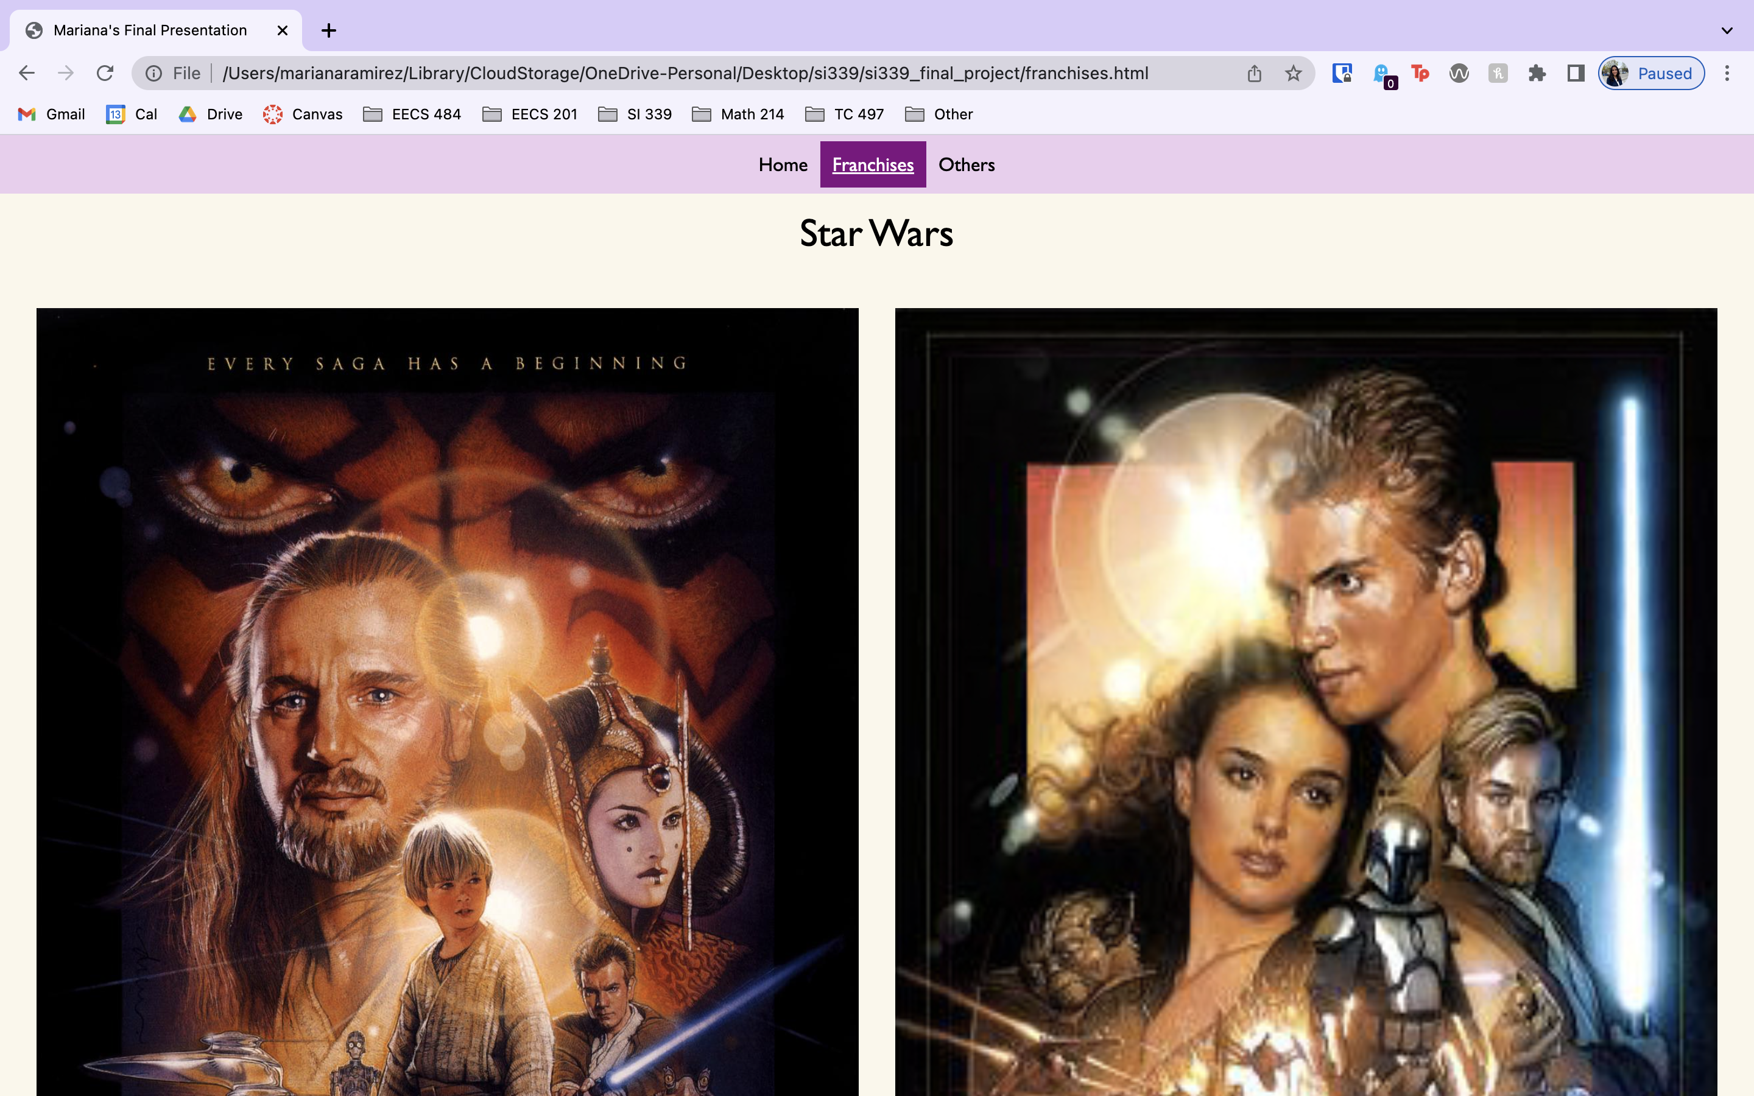

Figure - Without grid  
  
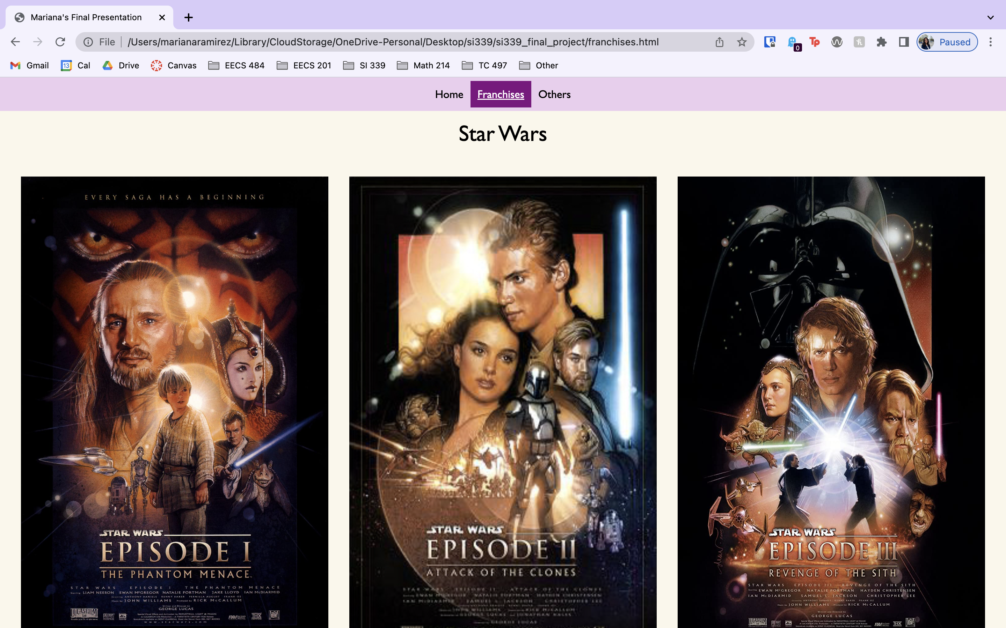

Figure - With grid

1. Which elements use flex and which pages are these elements on? How did you use flex differently from the homework? Which different supporting properties did you use, e.g flex-direction, flex-wrap, justify, align? Did you use Inspect Element to check that removing **display: flex** changes the page? (Include screenshot if desired.)  
     
   The images on the Others page uses flex and the navbar links. This is different from the homework because to change the appearance I used flex: x% to change the number of columns to make sure the images are legible. I used flex-direction: row, flex-wrap: wrap, and align and justify-content to perfectly center the flexbox. I did check with inspect element and the screenshots are below.  
     
   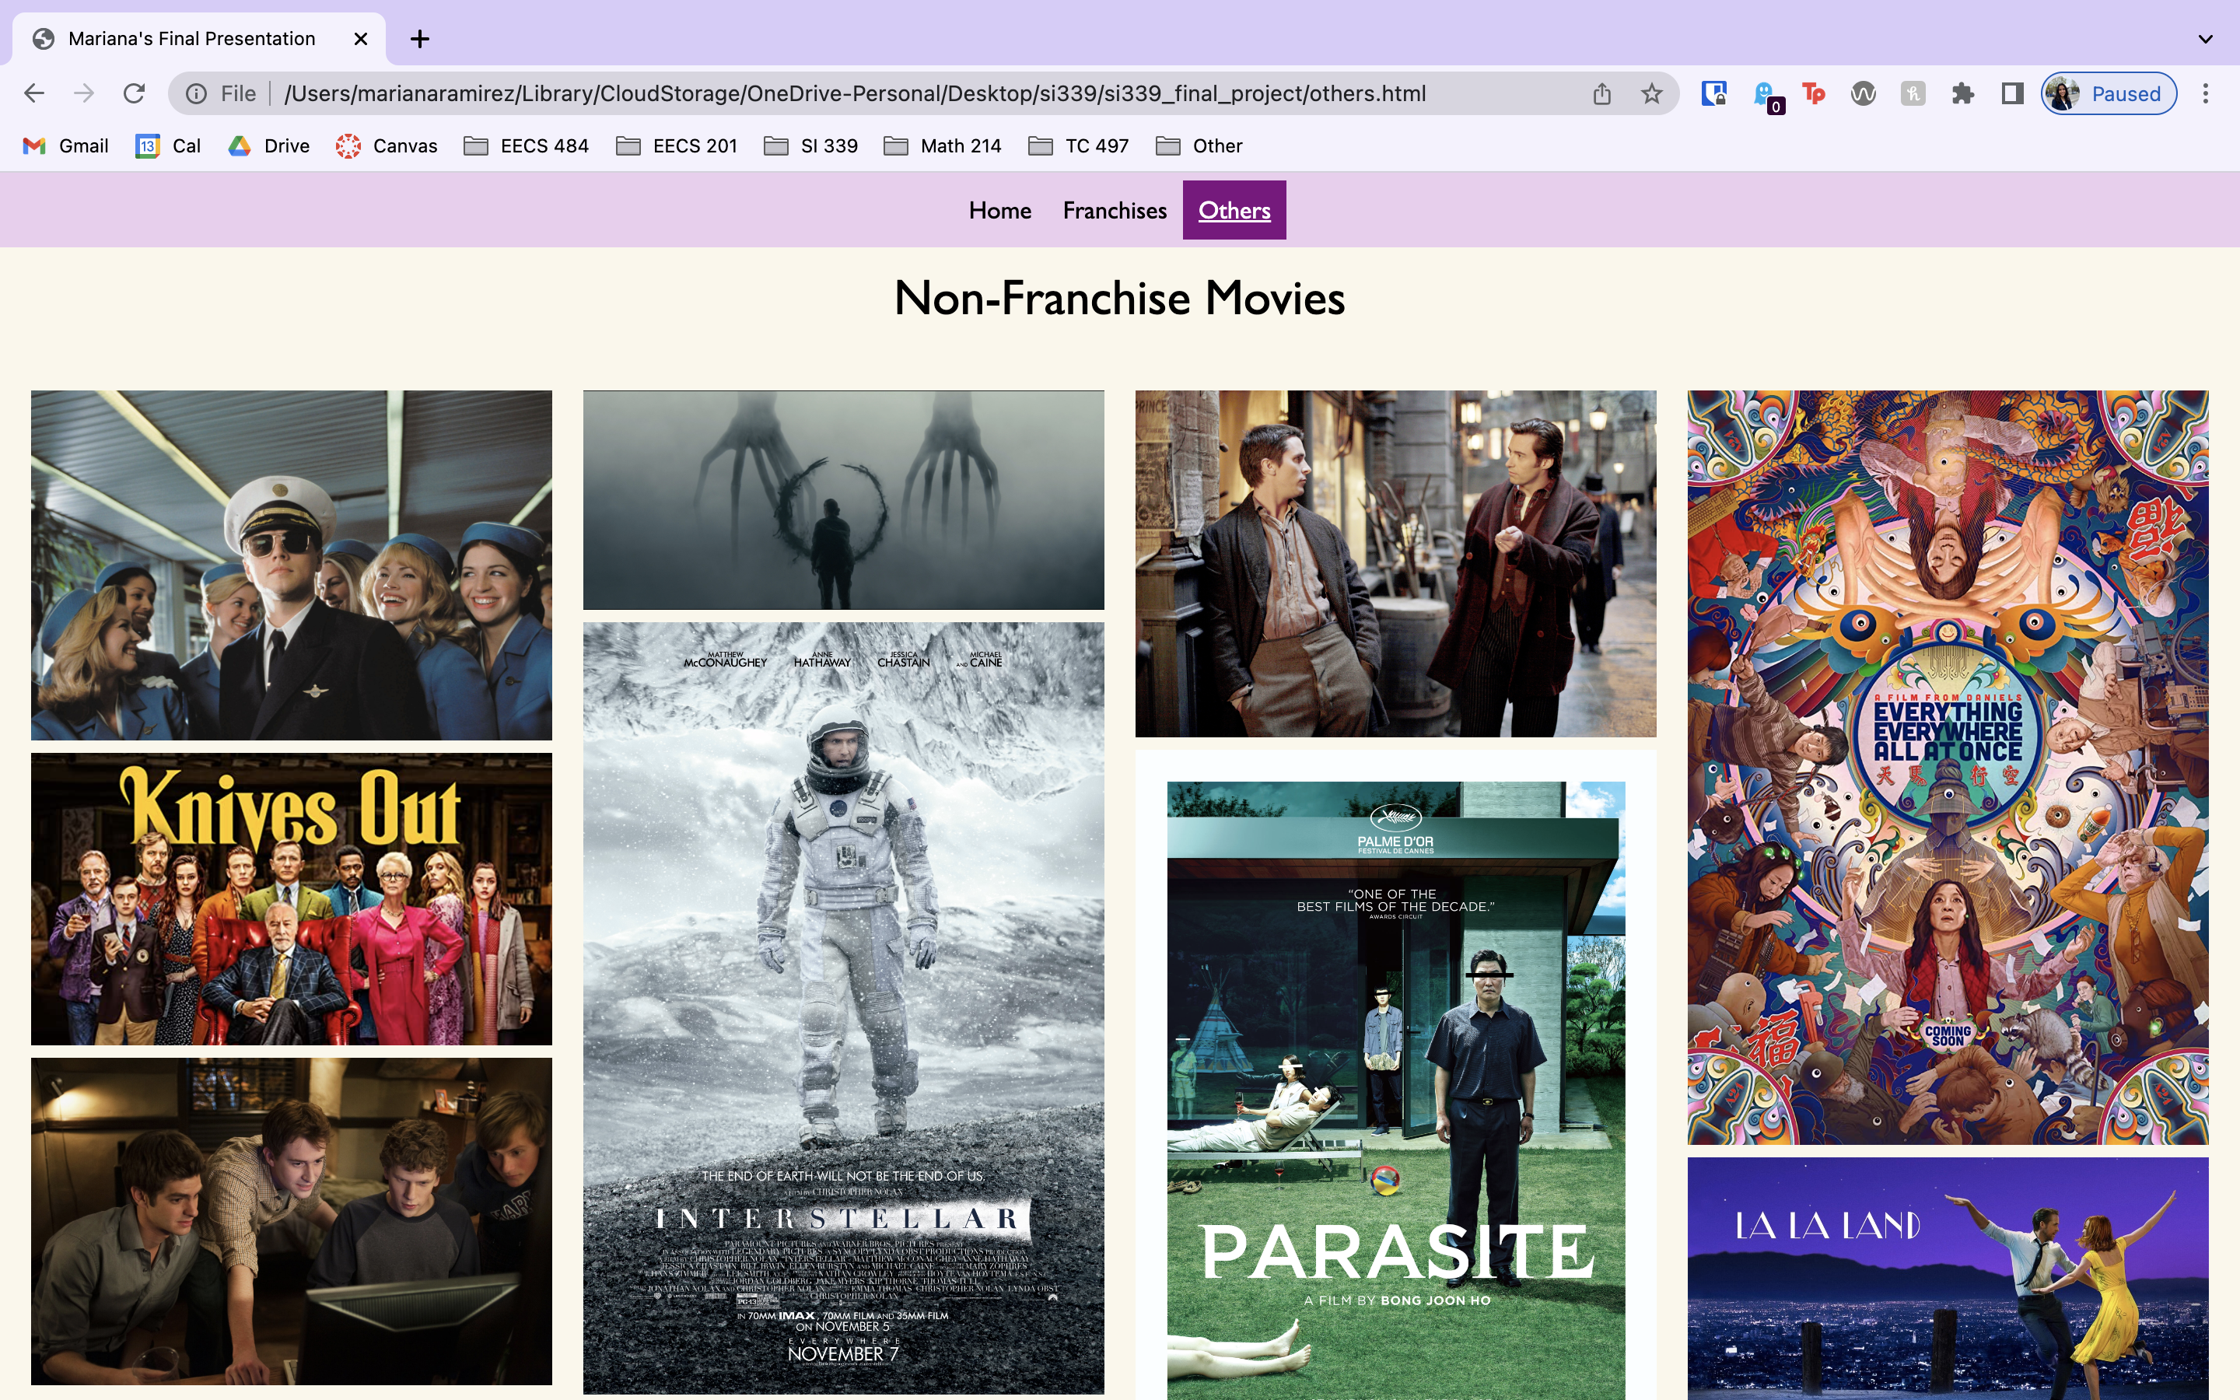

Figure - With flex

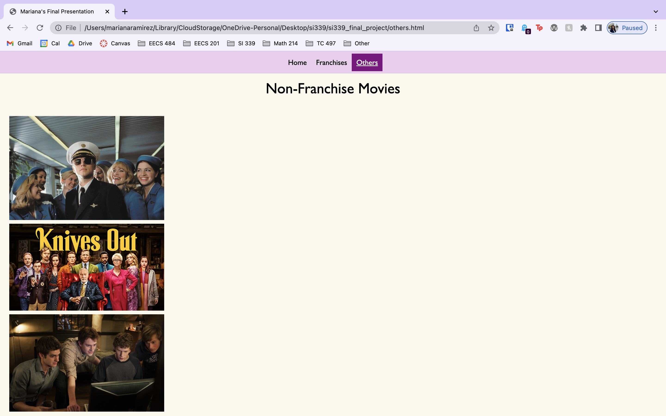

Figure - Without flex

1. What did you do to make your pages particularly visually appealing? How did you come up with your color scheme? Tell us more about your font choices, image editing, etc. I am sure there are things that you did that we can't easily see.  
     
   I made sure to use colors that weren’t too flashy or distracting, I didn’t clutter the smaller screen size with too much text, and I adjust the size of images to make sure they’re easily read. When picking the color scheme, I just played around with a hex color picker using the sliders and found some colors that worked well together. I tested out multiple color schemes before settling on the tan and purple one. I remembered liking the font from homework 5 so I used the same font as that homework assignment. I also tried to pick images that would fit well together, especially for the Others page.
2. Tell us about your Responsive Design. What is your tablet breakpoint and why did you pick that particular value for your first media query? What is changed in the layout? What is changed in the styling? ***How did these changes improve the page***? Were you careful to not duplicate unnecessary code?  
     
   The tablet breakpoint is 500px because it was a good in between size. On the home page I unhid the movie facts section which I thought was too much writing to place on the phone. On the Franchises page I switched from having the images appear one on top of the other to having a two-column grid. The flex items also use a two-column grid. These improve the page because I included more information with a bigger screen like with the movie facts section and I fit more pictures side by side to that the user doesn’t need to scroll through each picture individually to see them all. Yes, I only changed the necessary code.
3. Tell us about your Responsive Design. What is your desktop breakpoint and why did you pick that particular value for your first media query? What is changed in the layout? What is changed in the styling? ***How did these changes improve the page***? Were you careful to not duplicate unnecessary code?   
     
   The desktop breakpoint is 700px because this worked well for both my laptop and with my monitor which has a much bigger screen size. The grid and flex use three columns now that more pictures can fit side by side. This, again, makes it easier for the user to see all the pictures without having to scroll too much. Like before, I was still careful to not repeat code.
4. Include a screenshot of **all** pages validating on aXe and Wave. Make sure that we can see the URL in the screenshot.  
     
   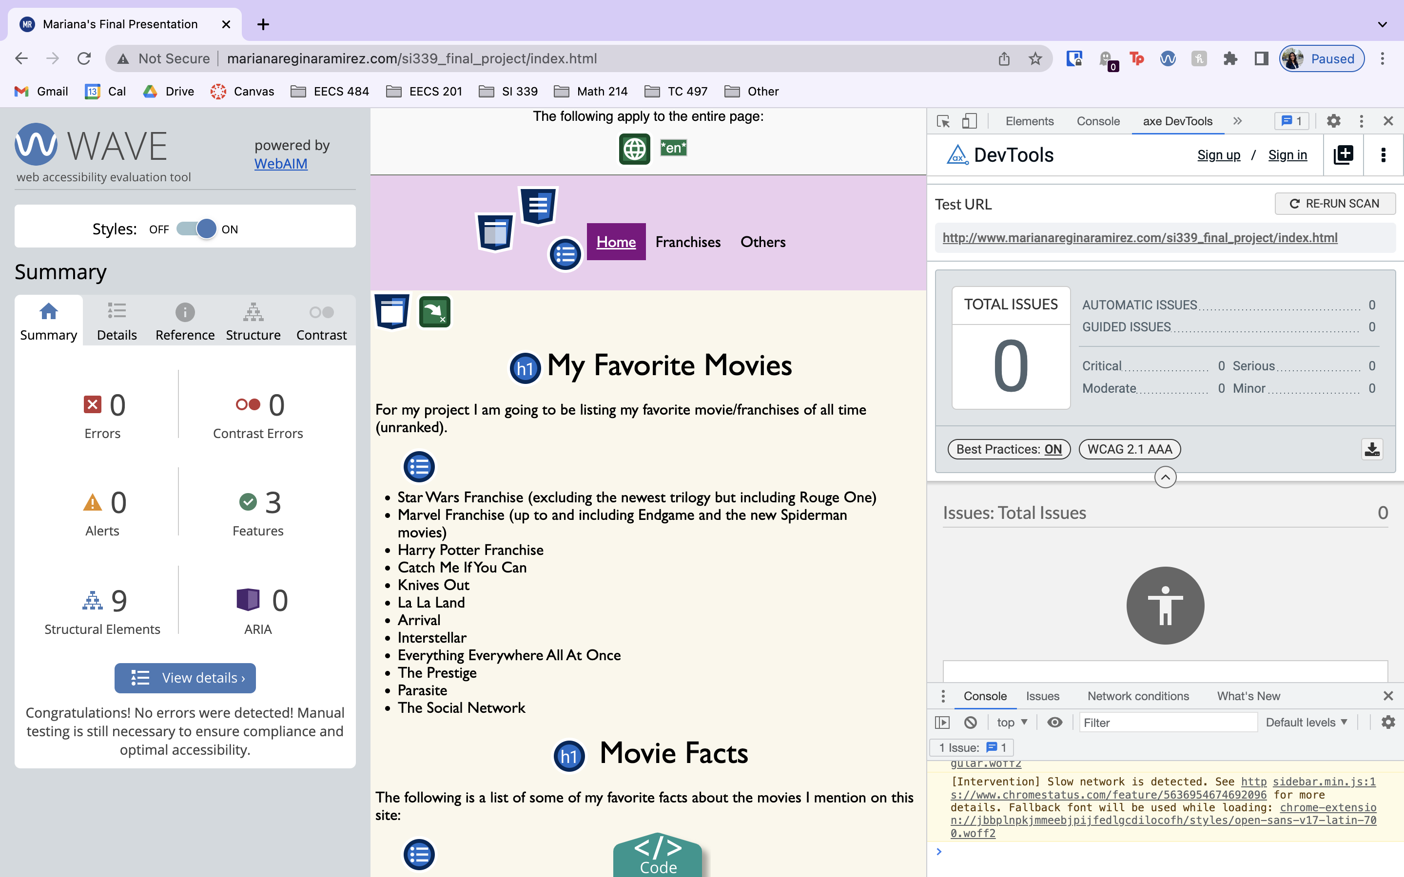  
     
   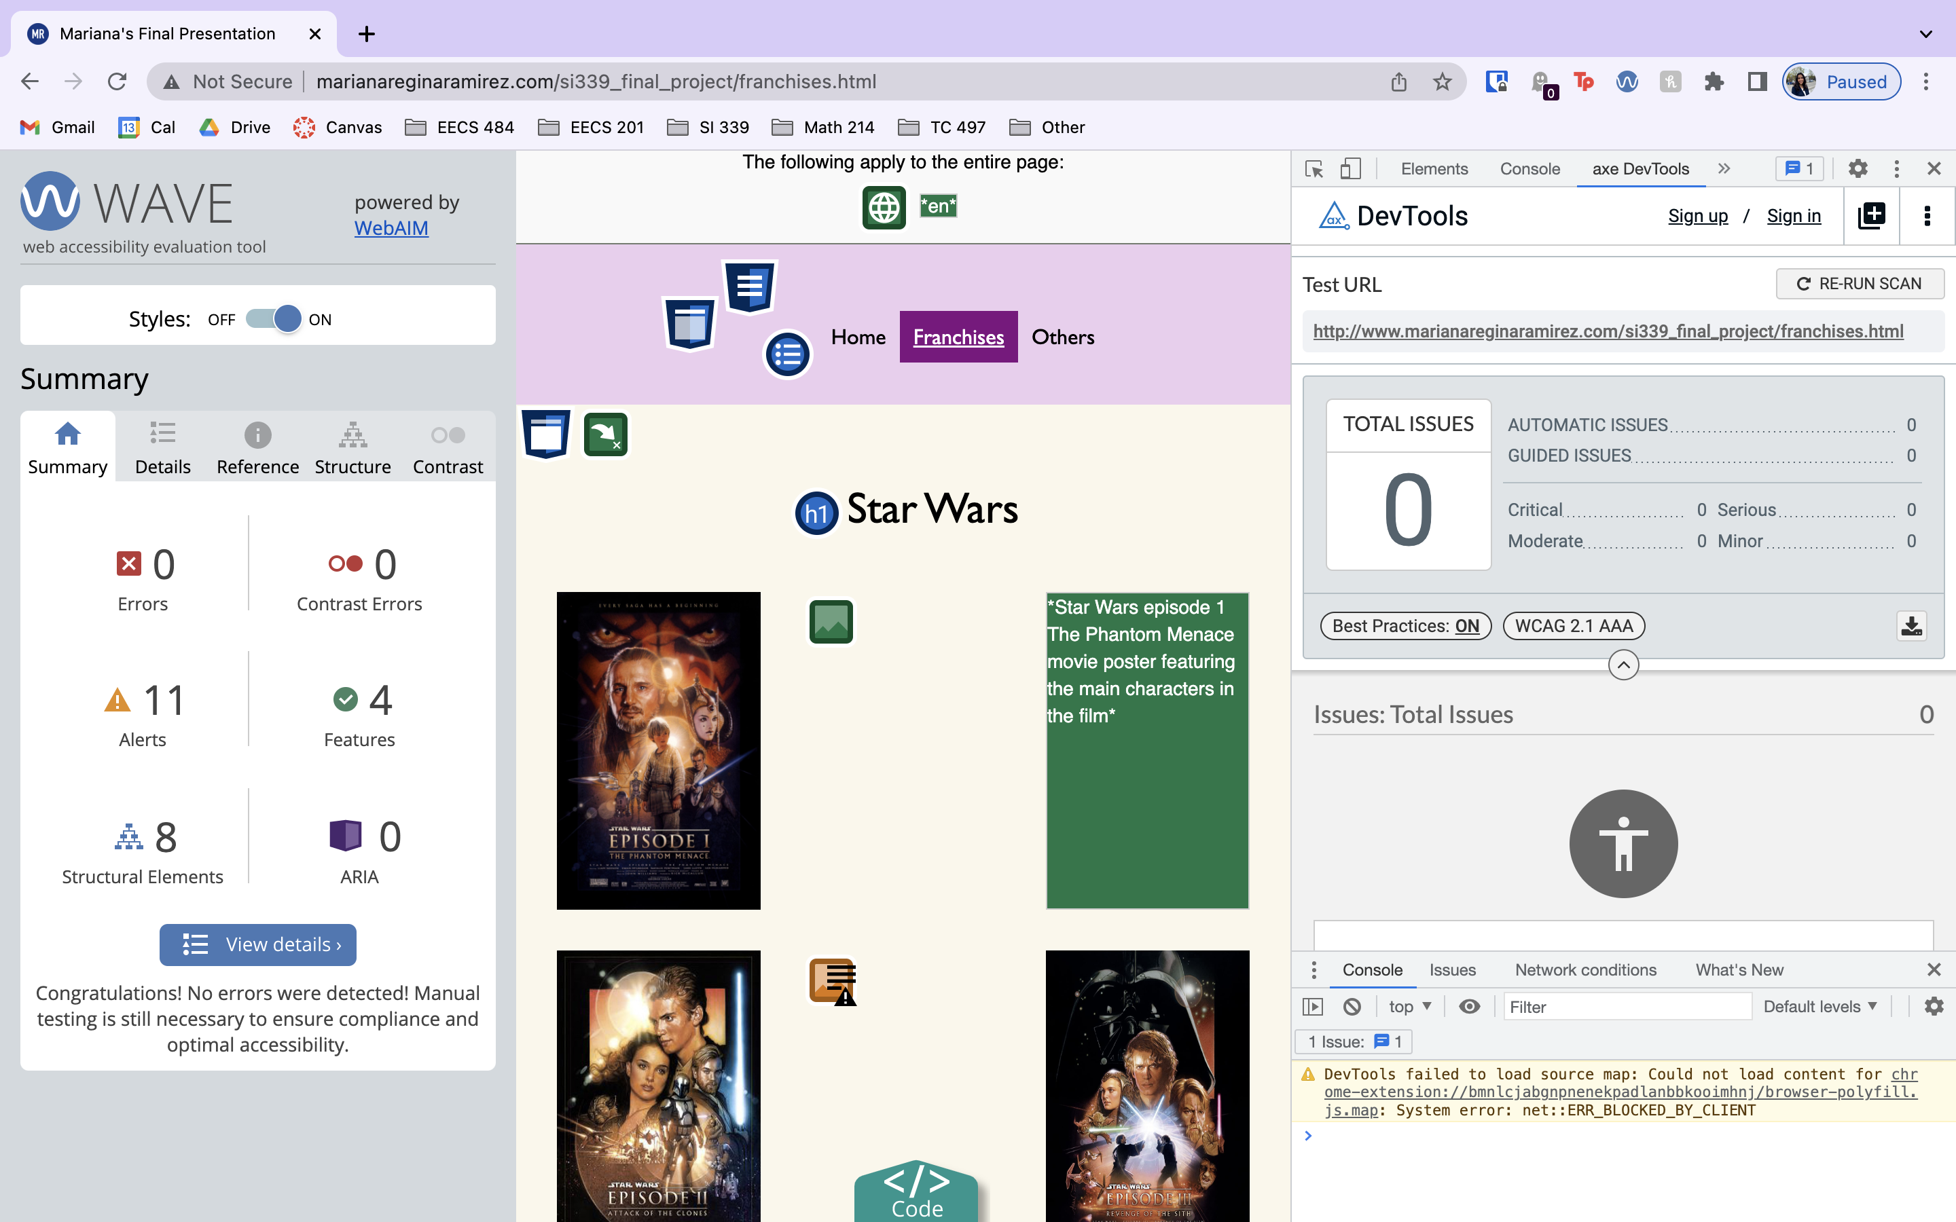  
     
   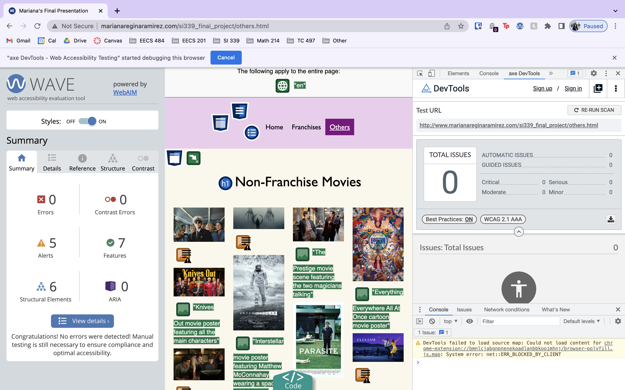
5. What ***extra*** steps you took to ensure that your site addresses accessibility, diversity and inclusion. Tell us about your pictures, topic, or additional manual testing.  
     
   I made sure to have very thorough alt text descriptions of what is depicted in each photo. Especially for the marvel phases 1-3 pictures I made sure to state which movies were part of each collage. Also, when changing the current active page I changed the background color, font color, and I underlined it for those who cannot see color very well. Additionally, I made sure to not have contrast errors with aXe or Wave.
6. Check your site for other issues. Are you using the html5reset style stylesheet? Did you remember to include the viewport meta tag? Do you have console errors? Did you use proper naming conventions (no uppercase letters or spaces, mnemonic file names, etc.)  
     
   Yes, I am using html5reset, I include the viewport meta tag, I do not have console errors, and I stick to proper naming convections.

Fill in your expected score and we will use it as a starting point. (If you give a lower score than we think you deserve we may raise it. If you give yourself credit for doing something you didn’t complete we will make an extra deduction.)

|  |  |  |
| --- | --- | --- |
| **Criteria** | **Your Expected Score** |  |
| The navigation must clearly display the current page within the nav element. As you visit each page, point out how the navigation bar changes to clearly indicate which page you are currently viewing. Don't forget, color alone should never be used to signify important information. | 5/5 |  |
| Each page should contain a main section that can be reached using a Jump to Content option with the first tab on the page. Main must be after the navigation. Make sure to check that "Skip To Content" works on EVERY page. | 5/5 |  |
| Grid - used effectively.  What elements use grid and which pages are these elements on? How did you use grid differently from the homework? | 10/10 |  |
| Flex - used effectively.  What elements use flex and which pages are these elements on? How did you use flex differently from the homework? | 10/10 |  |
| Visually appealing What did you do to make your page particularly appealing? How did you come up with your color scheme? Tell us more about your font choices, image editing, etc. I am sure there are things that you did that we can't easily see. | 20/20 |  |
| Tell us about your Responsive Design. What is your tablet breakpoint and why did you pick that particular value for your first media query? What is changed in the layout? What is changed in the styling ? Were you careful to not duplicate unnecessary code? | 10/10 |  |
| Tell us about your Responsive Design. What is your desktop breakpoint and why did you pick that particular value for your second media query? What is changed in the layout? What is changed in the styling ? Were you careful to not duplicate unnecessary code? | 10/10 |  |
| Validation | 10/10 |  |
| Accessibility, diversity and inclusion. Include a summary of the steps you took to ensure that your site addresses accessibility, diversity and inclusion. | 10/10 |  |
| Presentation | 10/10 |  |
| “Extras” – What did you do above and beyond the required? | 20/25 |  |